Git Ignore

- Create a sample .log file
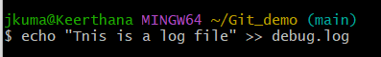

- Create a log folder and put a file inside it
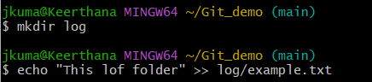

- Create .gitignore file and open it in notepad++
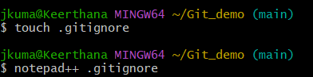

- Add these lines, save and close the editor
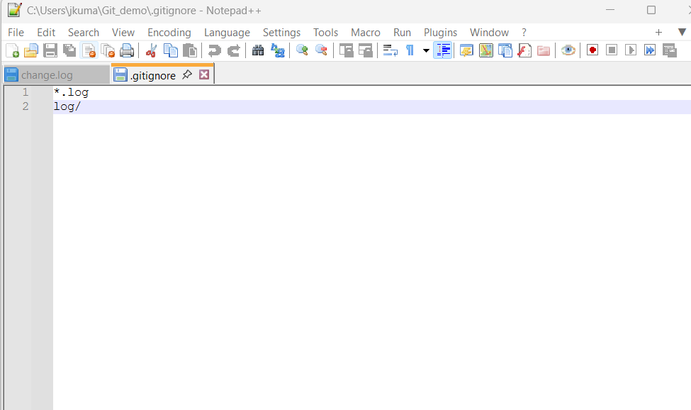
*.log → ignore all files ending in .log
log/ → ignore the entire log folder

- When we run git status, we should not see debug.log or the log folder listed as untracked files as they will be skipped
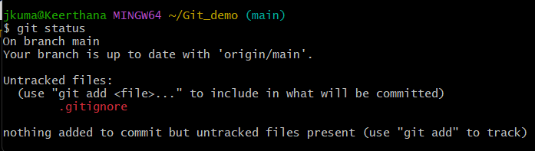

- Commit the .gitignore change
